Title of paper Here

Authors here
Affiliations here

ABSTRACT
Content here,
All text in Times New Roman 10, justified, single spacing, 6 pt spacing between paragraphs. All text content hereafter the same. Single column.
Not less than 2,000 words and not more than 5,000 words, with a 10-page limit (including words and figures), and no smaller than 10pt font.
Only papers with individual authorship will be considered.
The paper must not be written using any AI tools.
The paper must not previously be submitted on other platforms
- INTRODUCTION
Content formatted as above
- SUBSEQUENT MAIN HEADINGS
Text formatted as in Abstract
2.1 Sub headings
Content format as per Abstract

2.1.1 Minor headings
Content format as per Abstract
- Bulleted content indented 1 cm, not separated by line spacing
- May be numbered if desired

Table 1: Placed above table itself
Heading 1 | HEADING 2 | Heading 3 | Heading 4 | HEADING 5

Table to be typed directly on the page (not a jpeg), fit within margins, and centred on the page
Heading format optional

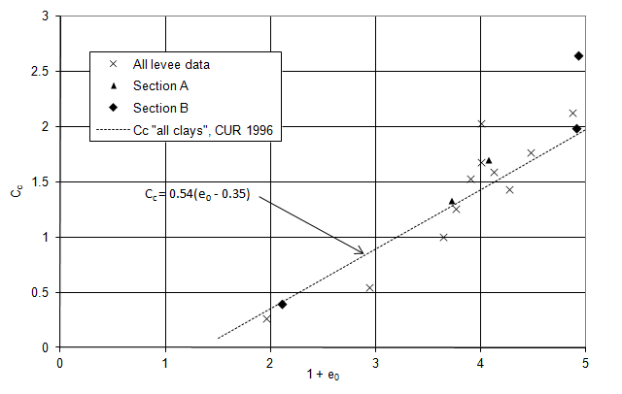
Figure 1: Placed below figure or photograph
Single Figures or sets of 2 smaller Figures to be within margins and centred on page. Figure to be an imported scan or jpeg. Graphs are NOT CONTRUCTED on the page

All equations/ formulae in italics, centred, with equation number aligned to right margin
$$α=D_{p}-3 (2)$$

References according to Harvard System, and listed in alphabetical order

Gaudin, C., Simkin, M., White, D.J. and O’Loughlin, C.D. (2010). Experimental investigation into the influence of a keying flap on the keying behaviour of plate anchors. Proc. 20th Int. Offshore and Polar Engineering Conf., Beijing, China, 533-540.
Juran, I., Bruce, D. A., Dimillio, A. & Benslimane, A. (1999). Micropiles: the state of practice. Part II: design of single micropiles and groups and networks of micropiles. Ground Improvement, 3(3), 89-110.
Kelleher, P.J. and Randolph, M.F. (2005). Seabed geotechnical characterisation with the portable remotely operated drill. Proc. Int. Symp. on Frontiers in Offshore Geotechnics (ISFOG), Perth, 365-371.

Do not number pages

